**IT2120- Probability and Statistics**Lab Sheet 6  
IT24102188  
Thathsarani P.H.H

Exercise  
  
1)

1. Binomial Distribution
2. 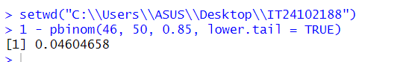

2)

1. number of customer calls received per hour
2. Poisson distribution
3. 